Callahan Fuel Reduction Project - Mechanical
BID PACKET

September 22, 2026
October 8, 2026

*Project Funded by a CAL FIRE Wildfire Prevention Grant*

Project Summary
The Callahan Fuel Reduction Project will occur on privately owned land surrounding the unincorporated community of Callahan and five miles east of the town of Etna in Scott Valley, California. Callahan and Etna are both listed as Communities at Risk by the Office of the State Fire Marshal, and the project falls entirely in areas identified as a Very High Fire Hazard Severity Zone. In the last five years alone, Callahan and Etna have been threatened by the River Complex (2021), Mountain (2022), and Shelly (2024) fires.

The project will treat approximately 139 acres of dense brush and overstocked stands of trees. Treatment will consist of plucking and piling or cutting brush and thinning trees under 10 inches in diameter to reduce hazardous fuel loading and ladder fuels. Any piles created will be burned to remove slash. Redistributing fuel loads and removing ladder fuels will moderate fire behavior by reducing flame lengths in the event of a wildfire. Ultimately, this will help protect these communities from catastrophic wildfire.

The majority of the project is planned adjacent to roadways around Callahan to protect essential egress and ingress routes for residents and emergency personnel. Treatment of these areas will allow for both safe evacuation and improved access for firefighters to engage in suppression and structure protection. Overall, this project will reduce wildfire severity and spread around Callahan and Etna and contribute to more fire-resilient communities. Funding for this project is provided by the California Department of Forestry and Fire Protection’s Wildfire Prevention Program.

The Shasta Valley Resource Conservation District (SVRCD) is acting as lead agency for this project. The SVRCD will administer the contract and serve as the primary contact during implementation.

Implementation must not begin before receiving the Notice to Proceed.

Contractor’s Obligations
The Bidder must analyze and respond to all sections of this Bid Packet providing detailed information to allow the SVRCD to evaluate the bids. The Contractor, by submitting its bids, agrees that any costs incurred by the Contractor in responding to this Bid Packet, are to be borne by Contractor and may not be billed to the SVRCD.
The Bidder must complete and submit all attachments in Appendix I, in the order listed. If the SVRCD has any confusion or difficulty in retrieving the required information from a Contractor’s bid, it may result in the disqualification of such bid.

Bid Submission Requirements
Submission of Bids:
Contractor should mail, hand deliver, or email their bid to the address listed below by 2pm on October 19th, 2026. Hard or electronic bids will be accepted.
Shasta Valley RCD
215 Executive Ct., Suite B
Yreka, CA 96097

For hard copy bids, the envelope shall be plainly marked in the upper left-hand corner with the name and address of the bidder and shall bear the words “Bid for the Callahan Fuel Reduction Project - Mechanical”.

Electronic bids shall be sent to Renee Main, Project Coordinator at rmain@svrcd.org. Please make the subject line “Bid for the Callahan Fuel Reduction Project - Mechanical” followed by your company’s name.

Critical Dates
Pre-bid Site Visit
Contractors wishing to bid on this project may attend a pre-bid site visit scheduled on October 7th, 2026, at 9:00am. Those interested will meet across from the Callahan Post Office (12436 CA-3 Callahan, CA 96014). Representatives of the SVRCD will be present to discuss the project.

Renee Main Project Coordinator
Email: rmain@svrcd.org
Phone: 406-580-3045

Contract Dates

The Contractor shall not begin operations until the Notice to Proceed is issued. All work shall be completed by December 31th, 2027.

Contractual Commitment of Bid
The contents of submitted bids will be considered obligations of the successful Contractor. No information should be submitted that is not intended to be incorporated into the bid and any contract, which may result from such bid. If there is any inconsistency between the terms herein and any of the contract documents, the terms in the contract documents shall prevail.

Project Specifications
The contractor is expected to follow the project specifications, site plans, permit requirements, and all state, county, and city laws and standards for this project.

The objective of this project is to reduce the fuel loading and fire hazard within the project area by eliminating the vertical and horizontal continuity of vegetative fuels to reduce the rate of fire spread, duration and intensity of fire, fuel ignitability and ignition of tree crowns or structures. Brush will be removed through pluck and pile to decrease the density of the understory and remove ladder fuels. Canopy spacing will be increased to 20 feet by removing trees up to 10-inch DBH. Dead and dying trees will also be removed.

Cutting Specifications:
- Pull and pile or masticate and remove trees ≤ 10” DBH to achieve a 20-foot canopy spacing. Some Oaks may be removed to allow access to brush. Maintain 20 foot spacing for retained oaks.
- Pull and pile or masticate all brush regardless of species.
- Any vegetation felled outside the project area will be brought back in for treatment
- Pull and pile or masticate and space conifer trees outside of the drip line of healthy oak trees. See property specifications below.
- Cut all stumps to less than 4 inches from the ground height
- Pile existing and created ground fuels; pre-existing logs < 12” in diameter will be piled
- Where slash, logs, or brush is piled, make piles approximately 10’x10’x10 unless located in an opening while pile size can be increased. Piles should be located at least 25 feet from retained healthy trees (bare dirt ring around pile not required).
- If mastication is utilized, slash depth shall not exceed 12”. Maximum slash length shall not exceed 2’.
- All effort shall be made to avoid damaging residual trees from mechanical equipment
- No heavy equipment on slopes greater than 50%, or on known slides or unstable areas. Any areas not accessible, brush will remain.

M1-Farrington
-Maintain Juniper trees 6’ and taller.
Protection of Cultural Resources
- A map of identified cultural resources will be provided. Contractor shall avoid disturbing these resources with equipment. Resources may be flagged with orange-and-white striped flagging.
- Discovery, by either the Contractor or the Shasta Valley Resource Conservation District, of cultural resources needing special protection shall be promptly reported to the Project Manager. Contractor shall immediately cease operations in the area. A perimeter of the protected resource shall be identified and avoided using orange-and-white striped flagging.

Protection of Sensitive Wildlife & Plant Species:
- Qualified SVRCD staff or a contracted biologist will complete surveys within 2 weeks prior to work beginning to detect any new active nests, roosts, dens, etc. or wildlife that cannot move out of the project area on its own. Exclusion areas will be established around any wildlife habitat elements. Buffer zones will also be placed around any special status plant species located in the project area. Surveys must be completed before implementation can begin.
- If wildlife is encountered during project activities, project work shall be paused to allow wildlife to leave area unharmed. Exclusion areas will be established around habitat elements such as active nests, dens, roosts, etc. Any such areas identified by Contractor must be reported to the Project Manager.
- In order to protect any species covered by the Migratory Bird Treaty Act (MBTA), fuels treatment between March 1 to August 31 must not occur until surveys are conducted by a biologist or a person with knowledge of, and ability to recognize, species protected by the MBTA and it is determined that there are no occupied nests within the proposed activity area. SVRCD staff or a contracted biologist will complete these surveys within 2 weeks prior to work beginning. If an MBTA species is located then no activities will occur within 100 feet of the nest during the breeding season (March 1- August 31).
- If Contractor discovers any sensitive wildlife or plant species, Contractor shall immediately contact the Project Manager and stop work within 100 feet of the sensitive species.

Protection of Aquatic & Riparian Habitat
- Class I streams will have buffers of 100 feet. Intermittent and perennial water bodies will have buffers of 50 feet and 75 feet, respectively. Buffers will be flagged with blue & white striped flagging. Use of equipment is not permitted within these buffers and disturbance of these areas should be minimized.
- If removal of vegetation within the riparian buffer is necessary, Project Manager will direct treatment of these areas. Treatment must be done by hand. At least 75% of the overstory and 50% of the understory canopy of native riparian vegetation will be retained within riparian buffers.

Erosion Control Work
- Activities that cause mechanical soil disturbance must stop when soils are saturated (i.e. when soil and/or surface material port spaces are filled with water to such an extent that runoff is likely to occur). Indicators of saturated soil conditions may include, but are not limited to: (1) areas of ponded water, (2) pumping of fines from the soil or road surfacing, (3) loss of bearing strength resulting in the deflection of soil or road surfaces under a load, such as the created of wheel ruts, (4) spinning or churning of wheels or racks that produces a wet slurry, or (5) inadequate traction without blading wet soil or surfacing materials.
- Limit heavy equipment that could cause soil disturbance or compaction to be driven through the treatment areas when soils are wet and saturated to avoid compaction and/or damage to soil structure. If use of heavy equipment is required in saturated areas, other measures such as operating on organic debris, using low ground pressure vehicles or operating on frozen soils/snow covered soils will be implemented to minimize soil compaction.
- Contractors will inspect treatment areas for implementation of erosion control prior to the rainy season. Contractors will inspect for evidence of erosion after the first large storm or rainfall event (i.e. ≥ 1.5 inches in 24 hours) as soon as is feasible after the event. Any area of erosion that will result in substantial sediment discharge will be remediated within 48 hours per the California Forest Practice Rules.
- Contractors will drain compacted and/or bare linear treatment areas capable of generating storm runoff via water breaks using the spacing and erosion control guidelines contained in Section 914.6, 934.6, and 954.6 (c) of the California Forest Practice Rules. Implementation will be by installing water breaks diagonally as a trench at least 6-inches into a firm ground base with a minimum of a 6-in berm on the downhill side so that water can be intercepted and directed away from the exposed surface. The exit area for the water must be free of blockages allowing for free flow of water. Water breaks shall be installed mid slope of control lines on slopes greater than 50% at 75 feet, 26-50% at 100 feet, 11-25% at 150 feet and 10% or less at 200 feet.
- The Project Manager may suspend contract in whole or in part when environmental damage may result from the operation of equipment included in this Contract. Operations shall not resume until approval is given by the Project Manager.

Boundaries:
- The boundaries depicted on the project area map delineate the treatment unit. Unit boundaries will be flagged with pink flagging. A georeferenced digital map will be provided to help Contractor identify unit boundaries using GPS assisted technology.
- Riparian buffer zones will be flagged with blue & white striped flagging. A georeferenced map of these areas will also be provided. Disturbance of these areas should be minimized. If removal of vegetation within the riparian buffer is necessary, project manager will direct treatment of these areas. No equipment will be permitted in riparian areas.
- Buffer zones for sensitive resources will be flagged with orange & white striped flagging. A georeferenced map of these areas will also be provided. Sensitive resource areas will be excluded from project work.
- In areas where the digital map differs from on-the-ground flagging, any flagging present will prevail as the boundary.

Safety:
- Contractor shall be responsible for initiating, maintaining, and supervising all safety precautions and programs in connection with the performance of the work.
- During the contract performance, Contractor shall protect the lives and health of workers performing the work and other persons who may be affected by the work and prevent damage to property adjacent to the project.
- Contractor shall comply with all applicable laws, ordinances, rules, regulations, and orders of any public body having jurisdiction for the safety, of persons or property or to protect them from damage, injury, or loss; and shall erect and maintain all necessary safeguards for such safety and protection.

Work progress:
Contractor’s operations shall progress in a workmanlike and orderly manner to avoid accidentally leaving untreated areas, with workers regularly connecting treated areas. At the end of each workday, no “islands” of untreated areas shall be left within areas that have been treated.

Payment Schedule
Contractor will be paid for expenses based on the invoices submitted monthly. The schedule is negotiable and will be refined during the contracting process. The SVRCD must receive invoices no later than the 5th of each month in order to adhere to the SVRCD’s billing schedule.
Payments to the contractors shall be paid within thirty (30) days from receipt of the funds by the SVRCD from the funding agency, which can be as much as three months after invoice submittal for this particular grant. SVRCD will make every effort to expedite payment to the contractor.

Additional Information
Site Location: This project is located on private land within and around the City of Callahan. See maps in Appendix II for more information.
Subcontracting: Any subcontractors must be identified along with the defined work they will perform on the bid form provided. The SVRCD will not refuse a bid based on the use of subcontractors but does retain the right to refuse the subcontractors selected. Contractor shall remain solely responsible for all subcontracted work.
Insurance: The Contractor is required to provide SVRCD with proof of appropriate insurance.
Limited Operational Periods: Work within may have periods where operations cannot be done due to species of concern or weather conditions. Current LOPs may be lifted with appropriate surveys completed to protocol.
Labor Compliance: Contractor agrees to be bound by all the provisions of the California State Labor code.
Maps and Measurements: The maps are provided as Attachments. They are intended to show only the general size, shape, and location of the areas. If the maps conflict with the field marking, the field markings shall govern. Positions of features are approximate. The units have been determined by Global Positioning Systems (GPS) and/or Geographic Information Systems (GIS). If re-measurement of the acreage is desired by the contractor, notification shall be made upon written request. Requests for re-measurement shall be made within 10 days after work has been completed on the unit.
Rework and Re-inspection after Rework: If contract specifications are not met as determined by Project Manager, payment may not be made until the problem has been corrected, unless the Project Manager determines that a reduction in pay in lieu of rework is acceptable.
Safety: When Contractor’s operations are in progress adjacent to or on all roads. Contractor shall furnish, install, and maintain all temporary traffic controls which provide the road user with adequate warning of hazardous or potentially hazardous conditions associated with Contractor’s operations.
Protection of Improvements and Survey Monuments: The Contractor shall avoid any damage to improvements such as, but not limited to: trails, telephone lines, pipelines, structures, roads, fences, gates, utility poles, power lines, pedestals, survey markers or monuments, and survey witness trees. The contractor will be required to repair or pay fair market value to replace any damaged improvements.
CERTIFICATION OF COMPLIANCE: Contractor shall certify compliance with specific fire precautionary measures included in the attached Fire Plan. The certification shall be made prior to commencement of work and shall be updated if at any time during performance the conditions change.

Attachments
Appendix I
- Bid Form Attachment No. 1: Contractor Information
- Bid Form Attachment No. 2: Proposed Subcontractors
- Bid Form Attachment No. 3: Bid Schedule
- Bid Form Attachment No. 4: Project Questionnaire
- Bid Form Attachment No. 5: Work Plan

Appendix II
- Exhibit A: Project Map
- Exhibit B: Fire Plan

Appendix I

BID FORM ATTACHMENT NO. 1: Contractor Information

General Information:

Company Name:
Company Address:
Contact Name:
Phone: |  | Fax:
Email: |  | Federal ID or SSN #:
Years in Business: |  | QAL (or equivalent) and LTO License #:

Bid Information
Bidder agrees to accept as full payment the following total base bid price:

________________________________________________ dollars
(in words)

________________________________________________________
(in numerals)

In the event of a discrepancy, amount in words shall prevail.

The bidder hereby acknowledges that the total base bid price is based solely on the bidder’s own estimate of costs and includes all applicable taxes, overheads, and profit.

Contractor Signature__________________________________________________________________

Additional bid Information: Please provide detailed information as outlined in the bid schedule below. Costs shown above should include all materials, labor, taxes, overheads, and profit, which must also be included in the following schedule.

BID FORM ATTACHMENT NO. 2: Proposed Subcontractors

The BIDDER should submit with the Bid Form a listing of names and business addresses of subcontracting firms or businesses that will be awarded subcontractors for portions of Work as described above.

The Subcontractor list shall be completed and should include the following information:
  - Subcontractors, listing each subcontractor whose subcontract amount is more than 10 percent of the Contract price with whom the bidder, if awarded the Contract, will subcontract for performance.
  - The categories of work those subcontractors will perform on the Contract.

A bid will be considered non-responsive and will be rejected if the BIDDER does not correctly complete the Subcontract List contained herein and include this Proposed Subcontractor list with the Bid Form.

- List of Subcontractors to be used
Subcontractor |  | Work |  | Dollar Amount |  | % of Total

BID FORM ATTACHMENT NO. 3: Bid Schedule

Task No. | DESCRIPTION (confirm based on plans and specifications) | QTY. | UNIT | UNIT PRICE | TOTAL
1.0 | Mechanical | 139 | ac
Total Bid Cost: |  | 139
Units: LS = Lump sum; ac = acre
Pay items Description:
- Mechanical
The bid price for this item shall include all equipment, manpower, mobilization, insurance, and bonding to complete the work described in the specifications to mechanical or handwork this 139 acres area. Mechanical work is for cut/pluck and pile or masticate. Remove trees ≤ 10” DBH and remove brush regardless of species. Pile slash, logs, or brush.

BID FORM ATTACHMENT NO. 4: Project Questionnaire

Please initial _ ____ if contractor has direct previous experience fulfilling labor compliance requirements, including, but not limited to, wage determinations, submission of payroll records, etc.

If no direct previous experience, please list below who will assist in meeting this requirement. Please include contact information and experience.
________________________________________________________________________________

BID FORM ATTACHMENT NO. 5: Work Plan

Please use the following space to describe in sufficient detail the work plan or methods you will employ to accomplish the project according to specifications. This will include a full description of how the project will meet the site requirements and prevent damage to infrastructure. You may attach a written response to this packet if needed. Please specify the equipment to be used for plucking and piling.

Attachments

Attachment A

Attached: Map of Project Area

Attachment B

Attached: Fire Plan

Exhibit A- Map
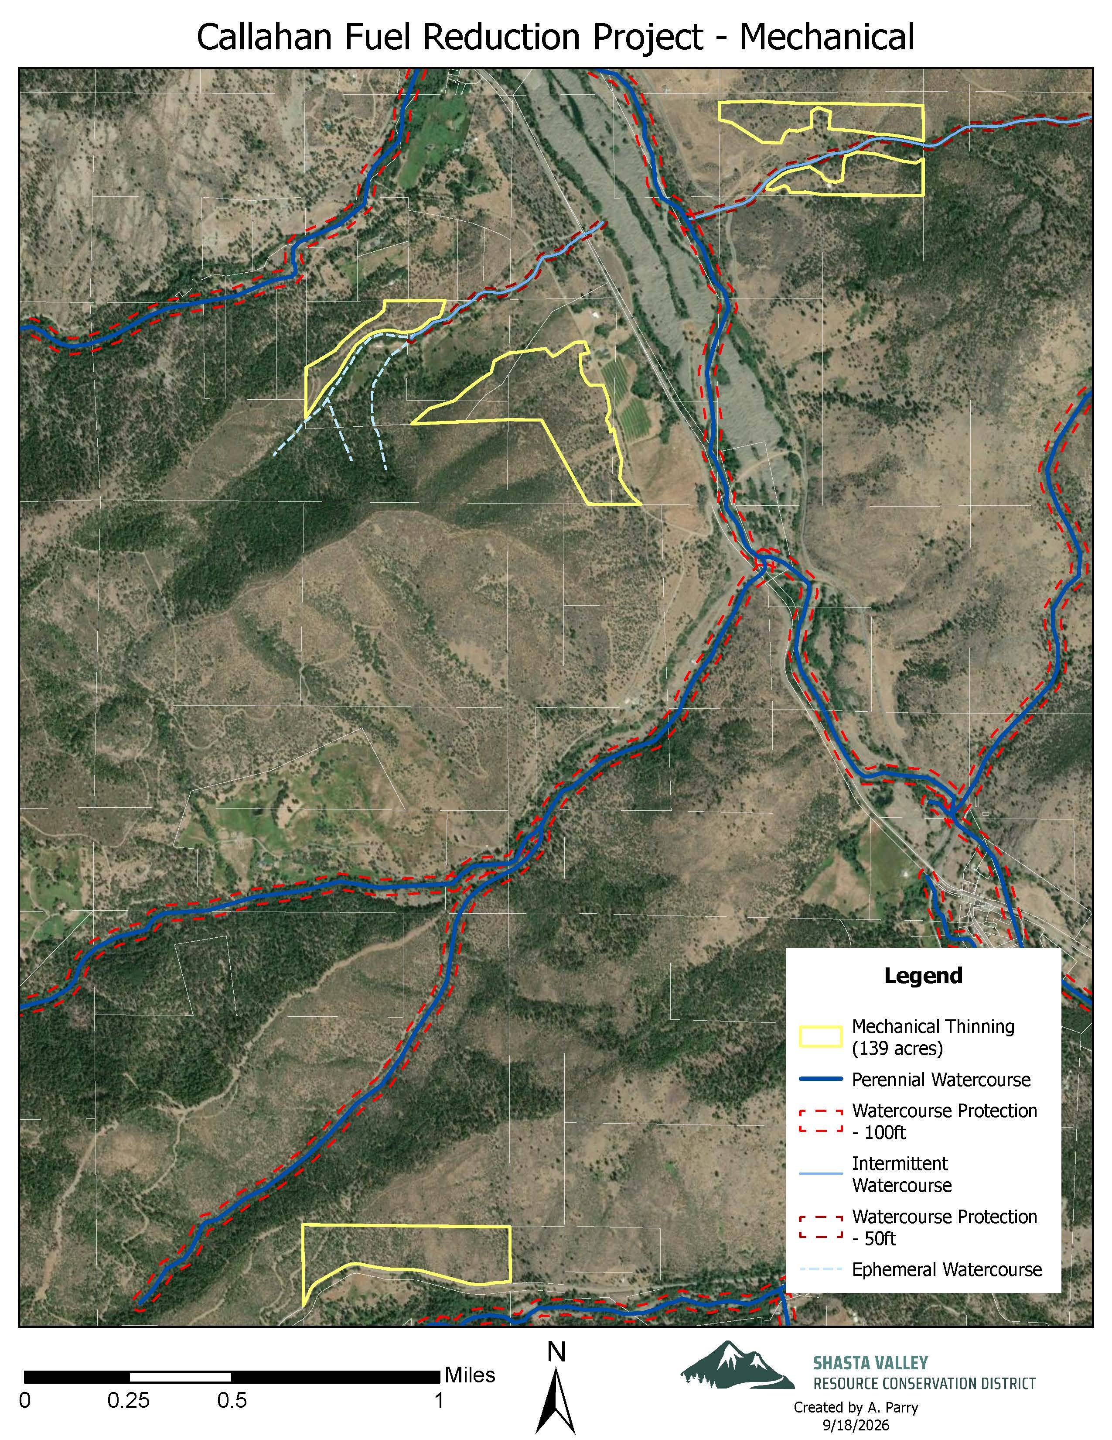
M1-Farrington
M4-M Thamer
M3-P Thamer
M2-Hilton

Exhibit B- Fire Plan

FIRE PLAN FOR CONSTRUCTION AND SERVICE CONTRACTS
- SCOPE:
The provisions set forth below outline the responsibility for fire prevention and suppression activities and establish a suppression plan for fires within the contract area. The contract area is delineated by map in the contract. The provisions set forth below also specify conditions under which contract activities will be curtailed or shut down.
- RESPONSIBILITIES:

Contractor
Shall abide by the requirements of this Fire Plan.
Shall take all steps necessary to prevent his/her employees, subcontractors and their employees from setting fires not required in completion of the contract, shall be responsible for preventing the escape of fires set directly or indirectly as a result of contract operations, and shall extinguish all such fires which may escape.
Shall permit and assist in periodic testing and inspection of required fire equipment. Contractor shall certify compliance with specific fire precautionary measures in the fire plan, before beginning operations during Fire Precautionary Period and shall update such certification when operations change.
- TOOLS AND EQUIPMENT:

The Contractor shall comply with the following requirements during the fire precautionary period, as defined by unit administering contracts:

The Fire Precautionary Period is set by the State of California which is April 1 through December 1 of any year.
A. Fire Tools and Equipment: Contractor shall meet minimum requirements of Section 4428 of the California Public Resources Code (C.P.R.C.). Fire tools kept at each operating landing shall be sufficient to equip all employees in the felling, yarding, loading, chipping, and material processing operations associated with each landing. All required fire tools shall be maintained in suitable and serviceable condition for fire fighting purposes.
Trucks, tractors, skidders, pickups and other similar mobile equipment shall be equipped with and carry at all times a size 0 or larger shovel with an overall length of not less than 46 inches and a 2-1/2 pound axe or larger with an overall length of not less than 28 inches.
B. Fire Extinguishers: Contractor shall equip each internal combustion chipper with a fire extinguisher for oil and grease fires (4-A:60-B:C).
All Fire Extinguishers shall be mounted, readily accessible, properly maintained and fully charged.
C. Spark Arresters and Mufflers: Contractor shall equip each operating tractor and any other internal combustion engine with a spark arrester, except for motor vehicles equipped with a maintained muffler as defined in C.P.R.C. Section 4442 or tractors with exhaust-operated turbochargers. Spark Arresters shall be a model tested and approved as shown in the. National Wildfire Coordinating Group Spark Arrester Guide, Volumes 1 and 2, and shall be maintained in good operating condition. Every motor vehicle subject to registration shall at all times be equipped with an adequate exhaust system meeting the requirements of the California Vehicle Code.
D. Power Saws: Each power saw shall be equipped with a spark arrester approved according to C.P.R.C. Section 4442 or 4443 and shall be maintained in effective working order. An Underwriters Laboratories (UL) approved fire extinguisher containing a minimum 14 ounces of fire retardant shall be kept with each operating power saw. In addition, a size 0 or larger shovel with an overall length of not less than 38 inches shall be kept with each gas can but not more than 300 feet from each power saw when used off cleared landing areas.
- GENERAL
A. State Law: In addition to the requirements in this Fire Plan, the Contractor shall comply with all applicable laws of the State of California. In particular, see California Public Resource Codes.
B. Smoking: Smoking shall not be permitted during fire season, except in a barren area or in an area cleared to mineral soil at least three feet in diameter. The Contractor shall sign designated smoking areas. Contractor shall post signs regarding smoking and fire rules in conspicuous places for all employees to see. Contractor's supervisory personnel shall require compliance with these rules. Under no circumstances shall smoking be permitted during fire season while employees are operating light or heavy equipment or walking or working in grass and woodlands.

C. Storage and Parking Areas. Equipment service areas, parking areas, and gas and oil storage areas shall be cleared of all flammable material for a radius of at least 10 feet unless otherwise specified by local administrative unit. Small mobile or stationary internal combustion engine sites shall be cleared of flammable material for a slope distance of at least 10 feet from such engine.

D. Reporting Fires: As soon as feasible but no later than 15 minutes after initial discovery, Contractor shall notify 911 emergency services of any fires on Contract Area or along roads used by Contractor. Contractor's employees shall report all fires as soon as possible.
When reporting a fire, provide the following information:
    - Your Name
    - Call back telephone number
    - Project Name
    - Location: Legal description (Township, Range, Section); and Descriptive location (Reference point)
    - Fire Information: Including Acres, Rate of Spread and Wind Conditions.

