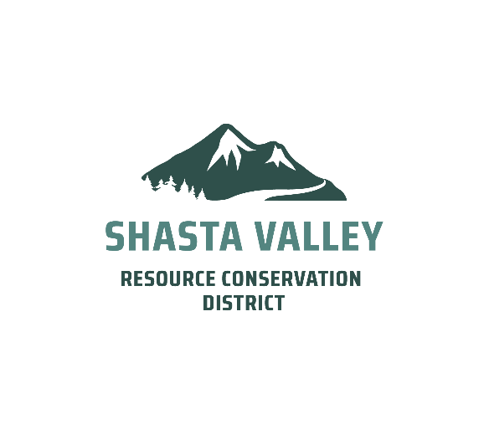

INVITATION TO BID

Slater Restoration - Handwork

Date: August 4th, 2026

RECEIPT OF BIDS: Sealed bids for implementation of the Slater Handwork Project will be received by the Shasta Valley Resource Conservation District. Sealed bids are to be delivered to the following address by September 4th, 2026, at or before 2:00 pm. Bids may be delivered electronically to dblessing@svrcd.org. Bids may also be hand delivered or mailed to the address below:

Shasta Valley Resource Conservation District
215 Executive Ct., Suite B
Yreka, CA 96097

OBTAINING BID DOCUMENTS: Copies of the BID DOCUMENTS may be obtained on or after August 5th, 2026. Bid documents can be found at the SVRCD website http://www.svrcd.org/contracting. If you plan to obtain bid documents at the pre-bid tour, please email Dan Blessing, Project Manager, at dblessing@svrcd.org to give notification of your interest in doing so.
DESCRIPTION OF WORK:
This fuel mitigation project is located in Happy Camp in Siskiyou County, California. The treatment will protect habitable structures in and around the community. The objective of this project is to provide immediate fuel mitigation to reduce fuel loading within the project area and to allow for prescribed fire lines to be created to facilitate underburning. Funding for this project is provided by the USDA Forest Service, State and Private Forestry through the California Association of Resource Conservation Districts.
PROJECT TIMELINE:
- Bid Packet Released August 4, 2026
- Pre-Bid Site Visit August 26, 2026 at 9:30 am
- Bids Due September 4, 2026 at 2:00pm
- Contract award by September 17, 2026
- All activities must be completed by November 30, 2026

CONTRACTOR EXPERIENCE: This project requires that the contractor is experienced in performing forestry work. References for similar projects may be requested as determined by the SVRCD Project Manager.
CONTRACTOR OBLIGATIONS, LICENSING AND REGISTRATIONS: Contractor agrees to be bound by all the provisions of the California State Labor code and shall monitor all contracts subject to reimbursement from this Agreement.

PRE-BID SITE VISIT: Contractors wishing to bid on this project may attend a pre-site visit on August 26, 2026, at 9:30 am. Please contact Dan Blessing at the email address above to confirm their attendance. Those interested will meet in Happy Camp at the corner of Highway 96 and Davis Road (Indian Creek Road). Representatives of the SVRCD and the City will be present to discuss the project.

PROJECT ADMINISTRATION: All questions relative to this project prior to the opening of bids shall be directed to Dan Blessing, Project Manager, at dblessing@svrcd.org. It shall be understood, however, that no interpretations of the specifications will be made by telephone.

SVRCD’S RIGHTS RESERVED: The SVRCD reserves the right to waive any informalities or to reject any or all bids, if in the best interest of the USDA Forest Service.

**This Project is funded by a USDA Forest Service Grant **

